**NAME: SUNDAY BENJAMIN**

**MODULE 2: COMMUNICABLE DISEASES**

**ASSIGNMENT 2**

**Question 1: Consider a disease known as diabetes mellitus, which is characterized by an increase in the blood sugar level. Infectious agents may contribute to the development of the disease in early childhood, but are not the main cause of the disease. Can it be classified as communicable? Explain your reasons**

Infectious agents like virus may contribute to development of the disease in early childhood by triggering the diabetic condition (Diabetes in Children, 2019), whose main cause may be attributed to genetics and the lifestyle of the children. It is mainly a condition where the pancreas is unable to secret the regulated amount of insulin in to the blood stream.

Diabetes mellitus may not be classified as communicable in a way that it deviates from the known characteristics of communicable diseases in the following ways:

1. *Infectious agent*; The disease is not caused by an infectious agent
2. *Reservior*; Since no infectious agents causes the disease, no reservoir can be found for an infectious disease, and therefore the disease cannot be transmitted from one living organism to another.
3. *Route of exit*; There isn’t a known exit route for diabetes mellitus
4. *Mode of transmission*; Diabetes mellitus cannot be transmitted by any means either direct or indirect from one person to another
5. *Route of entry*; Having no route of exit, the disease will have no route of entry to a host and therefore will not be able to be transmitted from one person to another

**Question 2: How would you classify pulmonary tuberculosis using the epidemiologic method? What is the main importance of such classification?**

From an epidemiologic stand point of classification, pulmonary tuberculosis may be characterized as an airborne disease, given the fact it is transmitted through the air.

The main importance of such classification is that by classifying diseases by the means of transmission instead of by the infectious causing agent, diseases with common means of transmission may be grouped together and prevented in a similar fashion or action plan, through targeting the means of being transmitted from one person or reservoir to the host.

**Question 3: Describe four or more bacterial vaccine-preventable diseases that have the same modes of transmission.**

The bacterial vaccine-preventable diseases that have the same mode of transmission through the respiration by coughing or sneezing are listed below:

1. *Meningitis*; This is an infection of the brain and spinal cord caused by meningococcus bacterium, mainly transmitted to a healthy person by airborne droplets from the nose and throat of infected people when they sneeze or cough.
2. *Diptheria*; This disease usually spreads from person to person, usually through respiratory droplets. A person may also get it by coming in contact with an object that has the bacteria causing agent on it. (Centers for Disease Control, n.d.)
3. *Tuberclosis*; This is a contagious infection that usually attacks the lungs, with the capacity to also spread to other parts of the body like the brain and spine. The germs with in your body may remain latent only awaiting activation through other infections like HIV, or they may become active within the body in which case they multiply to the rest of the body (WebMD, n.d.)
4. *Pnuemonia*; This is an infection of the lung tissue that can make it difficult to breath due to inflammation, fluid and pas. Pnuemonia often develops after a person has had a different infection, such as a head cold. This makes a person more vulnerable to other types of infections. It is also transmitted through the air.

**Question 4: What are the causes and methods for preventing bacterial meningitis?**

Bacterial meningitis is caused by different infectious agents as detailed below;

1. Meningococcal A,B,C,Y and W135
2. Streptococcus pneumonia
3. Neisseria meningitides

The methods of preventing bacterial meningitis are detailed below:

1. Early identification of cases and prompt treatment of cases. Symptoms need to be trained to all health workers and communities to know the early symptoms of meningitis in children
2. Massive education of people about symptoms and ways that it is transmitted from person to person; Campaign awareness through the media and events prepared are one way of targeting key messages to the public concerning transmission, prevention and case – reporting routes and channels.
3. Reporting of all cases of meningitis to the concerned authorities, for instance with the Ministry of Health, and concerned line ministries for proper action to be taken, that is even include isolation when needed.
4. Vaccinating of children against all the infectious agents of the disease, and giving further chance for those not vaccinated to be immunized against these bacteria. Policy may be put in place that support these activities.
5. It is equally important to keep distance away from the infected people, and isolating them from the healthy to reduce the risk of exposure to the infectious bacteria. This prevents them from further spreading the disease to the healthy
6. Washing hands at the critical times, and most especially after having been in contact with an infected person.
7. Boosting your immune system through having a proper balanced diet including fresh fruits and vegetables, whole grains, and lean proteins — and by getting regular exercise. Also, be sure to get the sleep you need (EveryDayHealth)

**Question 5: Explain two characteristics that illustrate how the Anopheles larvae are different from other mosquito larvae. Using illustration is advised**

The anopheles’ larvae are different from other mosquito larvae in the following ways:

1. Rest position of the larvae below the water surface; The anopheles’ larvae rest parallel to the water surface, while the rest of the mosquito larvae lie at an angle to the water surface

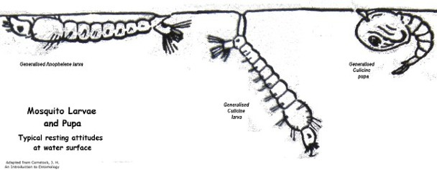

(mvmdistrict)

1. The respiratory siphon of anopheles larva is short and remains parallel to the water surface, while those of other mosquito larvae are long and form an angle inside the water.

(Animalia Life, n.d.)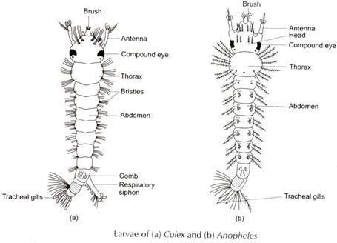

# Bibliography

(n.d.). Retrieved from https://www.mvmdistrict.com/mosquitoes.html

(n.d.). Retrieved from https://www.everydayhealth.com/hs/understanding-meningitis/prevent-meningitis-pictures/#boost-your-immune-system

(n.d.). Retrieved from https://www.cdc.gov/diphtheria/about/causes-transmission.html

(n.d.). Retrieved from https://www.webmd.com/lung/understanding-tuberculosis-basics#1

*Animalia Life*. (n.d.). Retrieved from http://animalia-life.club/other/mosquito-larvae-diagram.html

*Diabetes in Children*. (2019, June 10). Retrieved from Health Hearty: https://healthhearty.com/diabetes-in-children